**PROBLEM 1**

MAX Z = 4x1 + 6x2+x3

x1 <= 5

x2 <= 7

4x1 + 3x2+X3 <= 19

x1,x2,X3 >= 0

|  |  |  |  |  |  |  |  |  |  |  |  |  |  |  |  |  |  |  |
| --- | --- | --- | --- | --- | --- | --- | --- | --- | --- | --- | --- | --- | --- | --- | --- | --- | --- | --- |
|  | *Z* | - | 4 | *x*1 | - | 6 | *x*2 | -x3 |  |  |  |  |  |  |  |  | = | 0 |
|  |  |  |  |  | *x*1 |  |  |  | + |  | *S*1 |  |  |  |  |  |  | = | 5 |
|  |  |  |  |  |  |  |  | *x*2 |  |  |  | + |  | *S*2 |  |  |  | = | 7 |
|  |  |  |  | 4 | *x*1 | + | 3 | *x*2 | +x3 |  |  |  |  |  | + |  | *S*3 | = | 19 |

*x*1,*x*2,*S*1,*S*2,*S*3≥0

|  |  |  |  |  |  |  |  |  |
| --- | --- | --- | --- | --- | --- | --- | --- | --- |
| 1 | -4 | -6 | 0 | 0 | 0 | Z |  |  |
| 0 | 1 | 0 | 1 | 0 | 0 | X1 |  | 0 |
| 0 | 0 | 1 | 0 | 1 | 0 | X2 | = | 5 |
| 0 | 4 | 3 | 0 | 0 | 1 | X3 |  | 7 |
|  |  |  |  |  |  | S1 |  | 9 |
|  |  |  |  |  |  | S2 |  |  |
|  |  |  |  |  |  | S3 |  |  |

|  |  |  |  |
| --- | --- | --- | --- |
| 1 | 0 | 0 | 0 |
| 0 | 1 | 0 | 0 |
| 0 | 0 | 1 | 0 |
| 0 | 0 | 0 | 1 |

B1=

|  |  |  |
| --- | --- | --- |
| 1 | 0 | 0 |
| 0 | 1 | 0 |
| 0 | 0 | 1 |
| 0 | 0 | 0 |

B=

CB=( 0 0 0)

|  |  |  |  |  |  |  |  |
| --- | --- | --- | --- | --- | --- | --- | --- |
| ***B*** | ***XB*** | ***β*0** ***Z*** | ***β*1** ***S*1** | ***β*2** ***S*2** | ***β*3** ***S*3** | ***x*1** | ***x*2** |
| *Z* | 0 | 1 | 0 | 0 | 0 | -4 | -6 |
| *S*1 | 5 | 0 | 1 | 0 | 0 | 1 | 0 |
| *S*2 | 7 | 0 | 0 | 1 | 0 | 0 | 1 |
| *S*3 | 19 | 0 | 0 | 0 | 1 | 4 | 3 |

|  |  |
| --- | --- |
| -4 | -6 |
| 1 | 0 |
| 0 | 1 |
| 4 | 3 |

MAX ( 1 0 0 0)

MAX (4 6 1)

=6

|  |
| --- |
| -6 |
| 0 |
| 1 |
| 3 |

B1-1.a2=

|  |
| --- |
| 0 |
| 5 |
| 7 |
| 19 |

Xb=

Min( 7,19/3)

=6.333

|  |  |  |  |  |  |  |  |  |  |  |  |  |  |  |  |  |  |
| --- | --- | --- | --- | --- | --- | --- | --- | --- | --- | --- | --- | --- | --- | --- | --- | --- | --- |
| ***B*** | ***XB*** | | | | | | ***β*0** ***Z*** | ***β*1** ***S*1** | | ***β*2** ***S*2** | ***β*3** ***S*3** | | ***y*2 *Ck*-*Zk*** | | ORAN | ***x*1** | ***x*2** |
| *Z* | 0 | | | | | | 1 | 0 | | 0 | 0 | | -6 | | --- | -4 | -6 |
| *S*1 | 5 | | | | | | 0 | 1 | | 0 | 0 | | 0 | | --- | 1 | 0 |
| *S*2 | 7 | | | | | | 0 | 0 | | 1 | 0 | | 1 | | 7 | 0 | 1 |
| *S*3 | 19 | | | | | | 0 | 0 | | 0 | 1 | | 3 | | 6.3333 | 4 | 3 |
| *XB* | *β*1 | *β*2 | | *β*3 | | *y*2 |
| *R*1 | 0 | 0 | | 0 | | 0 | -6 |
| *R*2 | 5 | 1 | | 0 | | 0 | 0 |
| *R*3 | 7 | 0 | | 1 | | 0 | 1 |
| *R*4 | 19 | 0 | | 0 | | 1 | 3 |
| ***B*** | ***XB*** | | ***β*0** ***Z*** | | ***β*1** ***S*1** | | ***β*2** ***S*2** | | ***β*3** ***x*2** | | | ***y*2 *Ck*-*Zk*** | | **ORAN** | | ***x*1** | ***S*3** |
| *Z* | 38 | | 1 | | 0 | | 0 | | 2 | | |  | | --- | | -4 | 0 |
| *S*1 | 5 | | 0 | | 1 | | 0 | | 0 | | |  | | --- | | 1 | 0 |
| *S*2 | 0.6667 | | 0 | | 0 | | 1 | | -0.3333 | | |  | | --- | | 0 | 0 |
| *x*2 | 6.3333 | | 0 | | 0 | | 0 | | 0.3333 | | |  | | --- | | 4 | 1 |

*x*1=0,*x*2=6.3333,x3=0  
  
Max *Z*=38

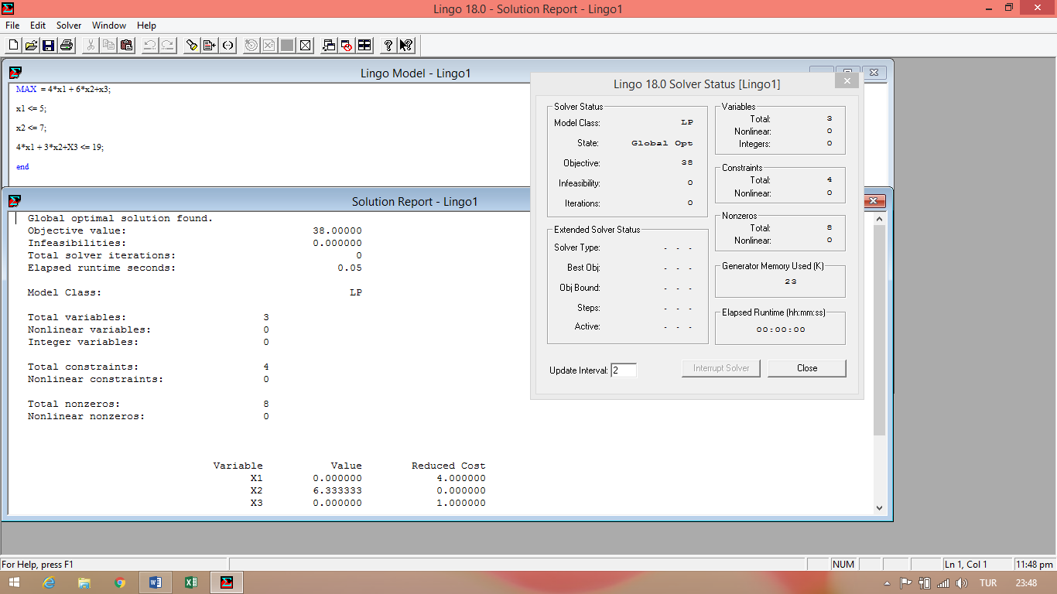

**PROBLEM 2**

MAX Z = x1 + 2x2 + 4x3  
  
x1 + x2 <= 6  
x2 + x3 <= 4  
x1 + x2 + x3 <= 13  
x1,x2,x3 >= 0

|  |  |  |  |  |  |  |  |  |  |  |  |  |  |  |  |  |  |  |  |  |  |  |  |  |  |  |  |  |  |  |  |  |  |  |  |  |  |  |  |  |  |  |  |  |  |  |  |  |  |  |  |  |  |  |  |  |  |  |  |  |  |  |  |  |  |  |  |  |  |  |  |  |  |  |  |  |  |  |  |  |  |  |  |  |  |  |  |  |  |  |  |  |  |  |  |  |  |  |  |  |  |  |  |  |
| --- | --- | --- | --- | --- | --- | --- | --- | --- | --- | --- | --- | --- | --- | --- | --- | --- | --- | --- | --- | --- | --- | --- | --- | --- | --- | --- | --- | --- | --- | --- | --- | --- | --- | --- | --- | --- | --- | --- | --- | --- | --- | --- | --- | --- | --- | --- | --- | --- | --- | --- | --- | --- | --- | --- | --- | --- | --- | --- | --- | --- | --- | --- | --- | --- | --- | --- | --- | --- | --- | --- | --- | --- | --- | --- | --- | --- | --- | --- | --- | --- | --- | --- | --- | --- | --- | --- | --- | --- | --- | --- | --- | --- | --- | --- | --- | --- | --- | --- | --- | --- | --- | --- | --- | --- |
| |  |  |  |  |  |  |  |  |  |  |  |  |  |  |  |  |  |  |  |  |  |  |  | | --- | --- | --- | --- | --- | --- | --- | --- | --- | --- | --- | --- | --- | --- | --- | --- | --- | --- | --- | --- | --- | --- | --- | | Z- | *x*1 | | - | 2 | | *x*2 | | - | 4 | *x*3 |  |  |  |  |  |  |  |  |  |  | = | 0 | |  | |  | |  |  | |  | *x*1 | + |  | *x*2 |  |  |  |  | + |  | *S*1 |  |  |  |  |  |  | = | 6 | |  | |  | |  |  | |  |  |  |  | *x*2 |  | + |  | *x*3 |  |  |  | + |  | *S*2 |  |  |  | = | 4 | |  | |  | |  |  | |  | *x*1 | + |  | *x*2 |  | + |  | *x*3 |  |  |  |  |  |  | + |  | *S*3 | = | 13 | |
| ,*x*1,*x*2,*x*3,*S*1,*S*2,*S*3≥0   |  |  |  |  |  |  |  |  |  |  | | --- | --- | --- | --- | --- | --- | --- | --- | --- | --- | | 1 | -1 | -2 | -4 | 0 | 0 | 0 | Z |  |  | | 0 | 1 | 1 | 0 | 1 | 0 | 0 | X1 |  | 0 | | 0 | 0 | 1 | 1 | 0 | 1 | 0 | X2 | = | 6 | | 0 | 1 | 1 | 1 | 0 | 0 | 1 | X3 |  | 4 | |  |  |  |  |  |  |  | S1 |  | 13 | |  |  |  |  |  |  |  | S2 |  |  | |  |  |  |  |  |  |  | S3 |  |  | |

|  |  |  |  |  |  |  |  |  |  |  |
| --- | --- | --- | --- | --- | --- | --- | --- | --- | --- | --- |
| ***B*** | ***XB*** | ***β*0** ***Z*** | ***β*1** ***S*1** | ***β*2** ***S*2** | ***β*3** ***S*3** | ***y*1 *Ck*-*Zk*** | **ORAN** | ***x*1** | ***x*2** | ***x*3** |
| *Z* | 0 | 1 | 0 | 0 | 0 |  | --- | -1 | -2 | -4 |
| *S*1 | 6 | 0 | 1 | 0 | 0 |  | --- | 1 | 1 | 0 |
| *S*2 | 4 | 0 | 0 | 1 | 0 |  | --- | 0 | 1 | 1 |
| *S*3 | 13 | 0 | 0 | 0 | 1 |  | --- | 1 | 1 | 1 |

MAX=( 1 2 4)

=4

|  |
| --- |
| -4 |
| 0 |
| 1 |
| 1 |

Y3=B-1a3=

|  |
| --- |
| 0 |
| 6 |
| 4 |
| 13 |

Xb=

Min=(4 13)

=4

|  |  |  |  |  |  |  |  |  |  |  |
| --- | --- | --- | --- | --- | --- | --- | --- | --- | --- | --- |
| ***B*** | ***XB*** | ***β*0** ***Z*** | ***β*1** ***S*1** | ***β*2** ***S*2** | ***β*3** ***S*3** | ***y*3 *Ck*-*Zk*** | **ORAN** | ***x*1** | ***x*2** | ***x*3** |
| *Z* | 0 | 1 | 0 | 0 | 0 | -4 | --- | -1 | -2 | -4 |
| *S*1 | 6 | 0 | 1 | 0 | 0 | 0 | --- | 1 | 1 | 0 |
| *S*2 | 4 | 0 | 0 | 1 | 0 | 1 | 4 | 0 | 1 | 1 |
| *S*3 | 13 | 0 | 0 | 0 | 1 | 1 | 13 | 1 | 1 | 1 |

|  |  |  |  |  |
| --- | --- | --- | --- | --- |
| *XB* | *β*1 | *β*2 | *β*3 | *y*3 |
| *R*1 | 0 | 0 | 0 | 0 | -4 |
| *R*2 | 6 | 1 | 0 | 0 | 0 |
| *R*3 | 4 | 0 | 1 | 0 | 1 |
| *R*4 | 13 | 0 | 0 | 1 | 1 |

|  |  |  |  |  |  |  |  |  |  |  |
| --- | --- | --- | --- | --- | --- | --- | --- | --- | --- | --- |
| ***B*** | ***XB*** | ***β*0** ***Z*** | ***β*1** ***S*1** | ***β*2** ***x*3** | ***β*3** ***S*3** | ***y*3 *Ck*-*Zk*** | **ORAN** | ***x*1** | ***x*2** | ***S*2** |
| *Z* | 16 | 1 | 0 | 4 | 0 |  | --- | -1 | -2 | 0 |
| *S*1 | 6 | 0 | 1 | 0 | 0 |  | --- | 1 | 1 | 0 |
| *x*3 | 4 | 0 | 0 | 1 | 0 |  | --- | 0 | 1 | 1 |
| *S*3 | 9 | 0 | 0 | -1 | 1 |  | --- | 1 | 1 | 0 |

MAX=(1 -2 4)

MAX=1

|  |  |  |  |  |  |  |  |  |  |  |
| --- | --- | --- | --- | --- | --- | --- | --- | --- | --- | --- |
| ***B*** | ***XB*** | ***β*0** ***Z*** | ***β*1** ***S*1** | ***β*2** ***x*3** | ***β*3** ***S*3** | ***y*1 *Ck*-*Zk*** | **ORAN** | ***x*1** | ***x*2** | ***S*2** |
| *Z* | 16 | 1 | 0 | 4 | 0 | -1 | --- | -1 | -2 | 0 |
| *S*1 | 6 | 0 | 1 | 0 | 0 | 1 | 6 | 1 | 1 | 0 |
| *x*3 | 4 | 0 | 0 | 1 | 0 | 0 | --- | 0 | 1 | 1 |
| *S*3 | 9 | 0 | 0 | -1 | 1 | 1 | 9 | 1 | 1 | 0 |

|  |  |  |  |  |
| --- | --- | --- | --- | --- |
| *XB* | *β*1 | *β*2 | *β*3 | *y*1 |
| *R*1 | 16 | 0 | 4 | 0 | -1 |
| *R*2 | 6 | 1 | 0 | 0 | 1 |
| *R*3 | 4 | 0 | 1 | 0 | 0 |
| *R*4 | 9 | 0 | -1 | 1 | 1 |

|  |  |  |  |  |  |  |  |  |  |  |
| --- | --- | --- | --- | --- | --- | --- | --- | --- | --- | --- |
| ***B*** | ***XB*** | ***β*0** ***Z*** | ***β*1** ***x*1** | ***β*2** ***x*3** | ***β*3** ***S*3** | ***y*1 *Ck*-*Zk*** | **ORAN** | ***S*1** | ***x*2** | ***S*2** |
| *Z* | 22 | 1 | 1 | 4 | 0 |  | --- | 0 | -2 | 0 |
| *x*1 | 6 | 0 | 1 | 0 | 0 |  | --- | 1 | 1 | 0 |
| *x*3 | 4 | 0 | 0 | 1 | 0 |  | --- | 0 | 1 | 1 |
| *S*3 | 3 | 0 | -1 | -1 | 1 |  | --- | 0 | 1 | 0 |

MAX=(-1 -3 -4)

**X1=6,X2=0,X3=4**

**MAXZ=22**

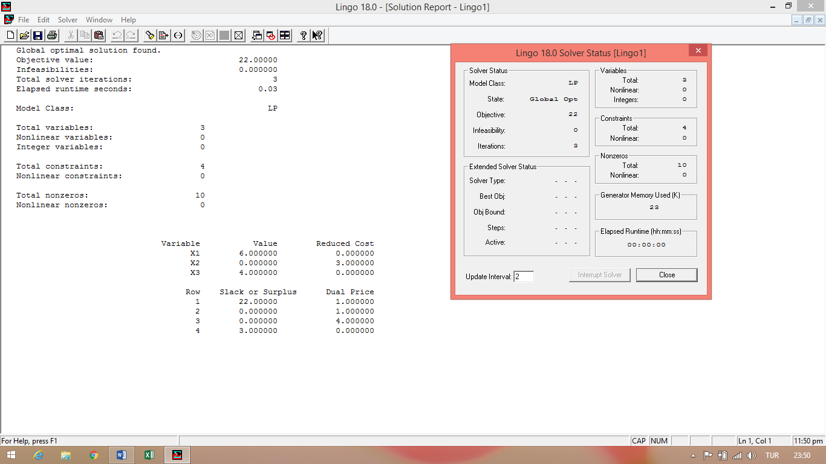

**PROBLEM 3**

MAX Z = 3x1 + 4x2 + 5x3

x1 + 2x2 <= 12

4x2 + 3x3 <= 32

x1 + x2 + 2x3 <= 10

x1,x2,x3 >= 0

|  |  |  |  |  |  |  |  |  |  |  |  |  |  |  |  |  |  |  |  |  |  |  |  |  |  |  |  |  |  |  |  |  |  |  |  |  |  |  |  |  |  |  |  |  |  |  |  |  |  |  |  |  |  |  |  |  |  |  |  |  |  |  |  |  |  |  |  |  |  |  |  |  |  |  |  |  |  |  |  |  |  |  |  |  |  |  |  |  |  |  |  |
| --- | --- | --- | --- | --- | --- | --- | --- | --- | --- | --- | --- | --- | --- | --- | --- | --- | --- | --- | --- | --- | --- | --- | --- | --- | --- | --- | --- | --- | --- | --- | --- | --- | --- | --- | --- | --- | --- | --- | --- | --- | --- | --- | --- | --- | --- | --- | --- | --- | --- | --- | --- | --- | --- | --- | --- | --- | --- | --- | --- | --- | --- | --- | --- | --- | --- | --- | --- | --- | --- | --- | --- | --- | --- | --- | --- | --- | --- | --- | --- | --- | --- | --- | --- | --- | --- | --- | --- | --- | --- | --- | --- |
| |  |  |  |  |  |  |  |  |  |  |  |  |  |  |  |  |  |  |  |  |  |  | | --- | --- | --- | --- | --- | --- | --- | --- | --- | --- | --- | --- | --- | --- | --- | --- | --- | --- | --- | --- | --- | --- | |  | *Z* | - | 3 | *x*1 | - | 4 | *x*2 | - | 5 | *x*3 |  |  |  |  |  |  |  |  |  | = | 0 | |  |  |  |  |  | *x*1 | + | 2 | *x*2 |  |  |  | + |  | *S*1 |  |  |  |  |  |  | = | 12 | |  |  |  |  |  |  |  | 4 | *x*2 | + | 3 | *x*3 |  |  |  | + |  | *S*2 |  |  |  | = | 32 | |  |  |  |  |  | *x*1 | + |  | *x*2 | + | 2 | *x*3 |  |  |  |  |  |  | + |  | *S*3 | = | 10 | |
| *x*1,*x*2,*x*3,*S*1,*S*2,*S*3≥0 |

|  |  |  |  |  |  |  |  |  |  |
| --- | --- | --- | --- | --- | --- | --- | --- | --- | --- |
| 1 | -3 | -4 | -5 | 0 | 0 | 0 | Z |  |  |
| 0 | 1 | 2 | 0 | 1 | 0 | 0 | X1 |  | 0 |
| 0 | 0 | 4 | 3 | 0 | 1 | 0 | X2 | = | 12 |
| 0 | 1 | 1 | 2 | 0 | 0 | 1 | X3 |  | 32 |
|  |  |  |  |  |  |  | S1 |  | 10 |
|  |  |  |  |  |  |  | S2 |  |  |
|  |  |  |  |  |  |  | S3 |  |  |
|  |  |  |  |  |  |  |  |  |  |

|  |  |  |  |  |  |  |  |  |  |  |
| --- | --- | --- | --- | --- | --- | --- | --- | --- | --- | --- |
| ***B*** | ***XB*** | ***β*0** ***Z*** | ***β*1** ***S*1** | ***β*2** ***S*2** | ***β*3** ***S*3** | ***y*1 *Ck*-*Zk*** | **ORAN** | ***x*1** | ***x*2** | ***x*3** |
| *Z* | 0 | 1 | 0 | 0 | 0 |  | --- | -3 | -4 | -5 |
| *S*1 | 12 | 0 | 1 | 0 | 0 |  | --- | 1 | 2 | 0 |
| *S*2 | 32 | 0 | 0 | 1 | 0 |  | --- | 0 | 4 | 3 |
| *S*3 | 10 | 0 | 0 | 0 | 1 |  | --- | 1 | 1 | 2 |

MAX=(3 4 5)

=5

MİN(32/3,10/2)

=5

|  |  |  |  |  |  |  |  |  |  |  |
| --- | --- | --- | --- | --- | --- | --- | --- | --- | --- | --- |
| ***B*** | ***XB*** | ***β*0** ***Z*** | ***β*1** ***S*1** | ***β*2** ***S*2** | ***β*3** ***S*3** | ***y*3 *Ck*-*Zk*** | **ORAN** | ***x*1** | ***x*2** | ***x*3** |
| *Z* | 0 | 1 | 0 | 0 | 0 | -5 | --- | -3 | -4 | -5 |
| *S*1 | 12 | 0 | 1 | 0 | 0 | 0 | --- | 1 | 2 | 0 |
| *S*2 | 32 | 0 | 0 | 1 | 0 | 3 | 10.6667 | 0 | 4 | 3 |
| *S*3 | 10 | 0 | 0 | 0 | 1 | 2 | 5 | 1 | 1 | 2 |

|  |  |  |  |  |
| --- | --- | --- | --- | --- |
| *XB* | *β*1 | *β*2 | *β*3 | *y*3 |
| *R*1 | 0 | 0 | 0 | 0 | -5 |
| *R*2 | 12 | 1 | 0 | 0 | 0 |
| *R*3 | 32 | 0 | 1 | 0 | 3 |
| *R*4 | 10 | 0 | 0 | 1 | 2 |

|  |  |  |  |  |  |  |  |  |  |  |
| --- | --- | --- | --- | --- | --- | --- | --- | --- | --- | --- |
| ***B*** | ***XB*** | ***β*0** ***Z*** | ***β*1** ***S*1** | ***β*2** ***S*2** | ***β*3** ***x*3** | ***y*3 *Ck*-*Zk*** | **ORAN** | ***x*1** | ***x*2** | ***S*3** |
| *Z* | 25 | 1 | 0 | 0 | 2.5 |  | --- | -3 | -4 | 0 |
| *S*1 | 12 | 0 | 1 | 0 | 0 |  | --- | 1 | 2 | 0 |
| *S*2 | 17 | 0 | 0 | 1 | -1.5 |  | --- | 0 | 4 | 0 |
| *x*3 | 5 | 0 | 0 | 0 | 0.5 |  | --- | 1 | 1 | 1 |

MAX=(1/2 3/2 5 /2)

=1.5

MİN=(6,6.8,10)

=6

|  |  |  |  |  |  |  |  |  |  |  |
| --- | --- | --- | --- | --- | --- | --- | --- | --- | --- | --- |
| ***B*** | ***XB*** | ***β*0** ***Z*** | ***β*1** ***S*1** | ***β*2** ***S*2** | ***β*3** ***x*3** | ***y*2 *Ck*-*Zk*** | **ORAN** | ***x*1** | ***x*2** | ***S*3** |
| *Z* | 25 | 1 | 0 | 0 | 2.5 | -1.5 | --- | -3 | -4 | 0 |
| *S*1 | 12 | 0 | 1 | 0 | 0 | 2 | 6 | 1 | 2 | 0 |
| *S*2 | 17 | 0 | 0 | 1 | -1.5 | 2.5 | 6.8 | 0 | 4 | 0 |
| *x*3 | 5 | 0 | 0 | 0 | 0.5 | 0.5 | 10 | 1 | 1 | 1 |

|  |  |  |  |  |
| --- | --- | --- | --- | --- |
| *XB* | *β*1 | *β*2 | *β*3 | *y*2 |
| *R*1 | 25 | 0 | 0 | 2.5 | -1.5 |
| *R*2 | 12 | 1 | 0 | 0 | 2 |
| *R*3 | 17 | 0 | 1 | -1.5 | 2.5 |
| *R*4 | 5 | 0 | 0 | 0.5 | 0.5 |

|  |  |  |  |  |  |  |  |  |  |  |
| --- | --- | --- | --- | --- | --- | --- | --- | --- | --- | --- |
| ***B*** | ***XB*** | ***β*0** ***Z*** | ***β*1** ***x*2** | ***β*2** ***S*2** | ***β*3** ***x*3** | ***y*2 *Ck*-*Zk*** | **ORAN** | ***x*1** | ***S*1** | ***S*3** |
| *Z* | 34 | 1 | 0.75 | 0 | 2.5 |  | --- | -3 | 0 | 0 |
| *x*2 | 6 | 0 | 0.5 | 0 | 0 |  | --- | 1 | 1 | 0 |
| *S*2 | 2 | 0 | -1.25 | 1 | -1.5 |  | --- | 0 | 0 | 0 |
| *x*3 | 2 | 0 | -0.25 | 0 | 0.5 |  | --- | 1 | 0 | 1 |

**X1=0,X2=6, X3=2 MAXZ=34**

